Smart security system


INTRODUCTION :-
    - Smart security refers to advanced security system that use technology that protect people and property .
    - It combines sensors , cameras and AI
    - The system can be moniter remotely using smart phones .

Key concepts:-
- Smart cameras
- smart locks
- Alarms
- cloud control
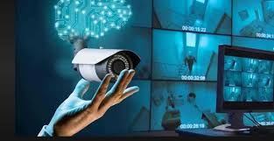

Working principles :-
- Alearts are sents to users phone.
- Camares capture videos and images .
- Sensors detect usual activity .

APPLICATIONS :-

HOME SECURITY
- OFFICE AND BANK SECURITY
- ATMS
- SHOPPING MALLS

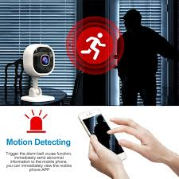

ADVANTAGES:-
- Quick alerts and responces
- Remote access and control
- Reduce human effect
- Increases safety and security



Conclusion :-
- Smart security system makes environment safer and smarter
- They help preventing and emergencies
- with feature advancement , smart secure will become more reliable and affordable

